The Title is Concise, Informative, and in 16-Point Bold Arial Font

First A. Author,^{1,2,*} Second B. Author,¹ and Third C. Author²
1: Department of First, Your Institute, City, NC, USA in 10-PT italics
2: Department of Second, Your Institute, City, Sate, ZIP, Country

Received May 1, 2015; Accepted July 1, 2015

The abstract is required for an article. The abstract has a maximum length of 200 words, and should be written in 10-point (PT) Arial font with an indent of 0.5 inch. The abstract should Inform about the main objectives and result of the review article or indicate the text structure. Do not do an extensive introduction here.

Keywords: First Keyword; Times New Roman; 10-PT italics; Up to 6 Keywords

Introduction

It is recommended that the overall length of a review article, submitted for publication in this journal have a length between 5 and 40 pages. The editors reserve the right to accept even longer articles in cases of exceptional quality of the work.
What is a review article? A review paper synthesizes the results from several primary literature papers to produce a coherent argument about a topic or focused description of a field. The purpose of a review paper is to succinctly review recent progress in a particular topic [1, 2]. Overall, the paper summarizes the current state of knowledge of the topic. It creates an understanding of the topic for the reader by discussing the findings presented in recent research papers.
Please indent all paragraphs, skip one line after each major heading, but not after subheadings. The introduction section provides information about the context, indicates the motivation for the review, defines the focus, and explains the text structure. Your introduction should make reference to key publications [3]. The format of the citations for EndNote® software can be downloaded from our website. Notice the form in which different kinds of citations appear at the end of the article [4-6]. Italics should be used for Latin words and contractions (i.e., viz., e.g., et al., etc.), for journal titles, and for genus and species (Escherichia coli).
Manuscripts must be submitted in either MS WORD, or RTF (Rich Text Format) format. Following these formats will facilitate the editing process and minimize the time between submission and publication. For purposes of the review process, the editorial staff will convert drafts to PDF (Portable Document Format) files.

Materials and Methods

Your Subheading in 12-point Arial
Systematic and best evidence reviews have a methods section. This section enables motivated researches to repeat the review. Narrative reviews do not have a methods section but should include some information about applied methods at the end of the introduction.

Your third-level heading
In case you want three levels of headings, please use non-bolded italics, with a Times New Roman 12-point font for the lowest level headings. Capitalize only the first word in the heading.

Another third-level heading
Most articles are likely to have only two levels of headings.

Your Subheading
The material and methods section contains information about data sources (e.g. bibliographic databases), search terms and search strategies, selection criteria (inclusion/exclusion of studies), the number of studies screened, the number of studies included, and statistical methods of meta analysis.

Body: Main Part of the Review Article

A coherent structuring of the topic is necessary to develop the section structure [3]. Subheadings reflect the organization of the topic and indicate the content of the various sections. Possible criteria for structuring the topic are methodological approaches, models or theories, extent of support for a given thesis, studies that agree with another versus studies that disagree, chronological order, and geographical location.
Each paragraph shall cover one idea, aspect or topic. Avoid referring to only one study per paragraph; consider several studies per paragraph instead. Frequently link the discussed research findings to the research question stated in the introduction. These links create the a thread of coherence in your review article. Link the studies to one another. Compare and discuss these relationships.
According to Ridley [6] three tenses are frequently used. Present is used to report what another author thinks, believes, and writes, reporting current knowledge or information of general validity (e.g. It is believed...). Simple past is referring to what a specific researcher did or found, referring to a single study, (e.g. They found...). Present perfect is referring to an area of research with a number of independent researchers involved, (e.g. They have found...).
Citations are usually indirect but in some cases pointed and relevant remarks might be cited directly. Non-integral references emphasize the idea, result, theory etc. rather than the person behind it [6]. Most references are non-integral. Integral references (direct): The author’s name has a grammatical function in the text. As Ridley points out this type is appropriate to emphasize the contribution of a specific author.

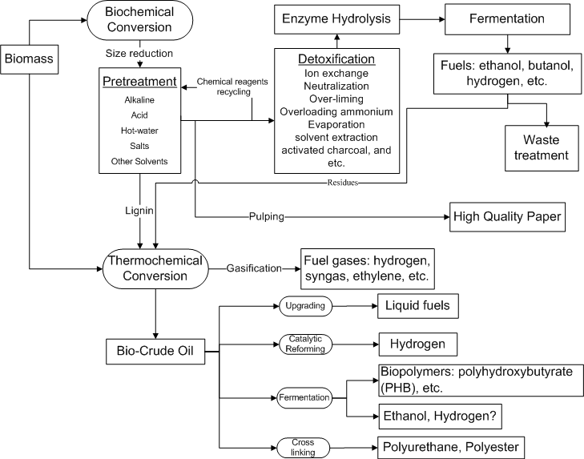
Figure 1. Example of a figure, prepared so that the axis labels are near to the size of the surrounding text. Note that the caption is 10-point Arial font with left justification [7, 8].

Copyrighted Materials and Fair Use

You must obtain the necessary written permission to include materials in your article that is owned and held in copyright by a third party, including but not limited to any proprietary text, illustration, table, or other material, including data, audio, video, film stills, screenshots, musical notation, and any supplemental material. The instruction of obtaining permission is available on the website of each publisher. The processing procedure takes between minutes and several weeks. In case that you want to use copyrighted figures, tables, and texts, start the application as early as possible.
A fair use of copyrighted material is allowed. This issue is within the Law scope. The 1961 Report of the Register of Copyrights on the General Revision of the U.S. Copyright Law cites examples of activities that courts have regarded as fair use: “quotation of excerpts in a review or criticism for purposes of illustration or comment; quotation of short passages in a scholarly or technical work, for illustration or clarification of the author’s observations; use in a parody of some of the content of the work parodied; summary of an address or article, with brief quotations, in a news report; reproduction by a library of a portion of a work to replace part of a damaged copy; reproduction by a teacher or student of a small part of a work to illustrate a lesson; reproduction of a work in legislative or judicial proceedings or reports; incidental and fortuitous reproduction, in a newsreel or broadcast, of a work located in the scene of an event being reported.”

Table 1. Table title-12PT
Table Content in10-PT
1
2
3
4

Plagiarism and Self-Plagiarism, a Secondary Heading

Plagiarism is the copying of ideas, text, data and other creative work (e.g. tables, figures and graphs) and presenting it as original research without proper citation. There are no legal rules permitting the use of a specific number of words, a certain number of musical notes, or percentage of a work. Whether a particular use qualifies as fair use depends on all the circumstances.
Indiana University (https://www.indiana.edu/~istd/examples.html) defined the word-for-word plagiarism as “when a writer takes a sequence of 7 or more words from another source, but fails to identify the quoted passage, fails to provide the full in-text citation crediting the author(s), and fails to provide the bibliographic reference.” We define the “word-for-word plagiarism” as the author(s) takes a sequence of 6 or more words from another source without appropriate citation.
Self- plagiarism: "Authors who submit a manuscript for publication containing data, reviews, conclusions, etc., that have already been disseminated in some significant manner (e.g., published as an article in another journal, presented at a conference, posted on the internet) must clearly indicate to the editors and readers the nature of the previous dissemination." (http://ori.hhs.gov/images/ddblock/plagiarism.pdf)
To avoid plagiarism, you may paraphrase, i.e. transfer original text into your own words.

CONCLUSIONS

Answer the research question set in the introduction (maximum 150 words). This section may include implications of the findings, interpretations by the authors, and identification of unresolved questions.

ACKNOWLEDGMENTS

This research was supported by a grant from the USDA, Grant. No. 2015-1234. Express gratitude to people who helped with the literature search, the structuring of the material or in the writing process.

REFERENCES

- The reference style of this journal is based on the APA (6th) standard. An Endnote style file can be downloaded from our website.
- A maximum of 75 references is allowed for a review paper.
- Following are sample references. The DOI number is required if available, because our publisher is the member of CrossRef.
- Bem, D. J. (1995). Writing a review article for Psychological Bulletin. Psychological Bulletin, 118 (2), 172-177. doi: 10.1037/0033-2909.118.2.172
- Billoski, T. V. (1992). Introduction to Paleontology, Institutional Press, New York.
- Schwartz, M. T., and Billoski, T. V. (1990). Greenhouse hypothesis: effect on dinosaur extinction. Extinction, B. T. Jones, and N. V. Lovecraft, eds., Barnes and Ellis, New York, 175-189.
- Ridley, D. (2008). The literature review - a step-by-step guide for students, Sage Publications, London.
- LaMotte (2011). Lamotte Smart 3 colorimeter manual. http://www.geotechenv.com/Manuals/LaMotte_Manuals/smart3_colorimeter_operators_manual.pdf. [Accessed on February 20, 2015]
- Author, F. A., Author, S. B., & Author, T. C. (2015). The Title is Concise, Informative, and in 16-Point Bold Arial Font. Trends in Renewable Energy, 1(1), X-Y. doi: 10.17737/tre.2015.1.1.00XX

